Assignment 6 CSCI4041

DUE: **Thursday**, Dec 8 10:00pm (+1hr55m grace period) Fall 2016

Wyatt Kormick

Kormi001

4932481

1. Given a directed graph G = (V,E) with a reliability measure r(u,v) in the range [0..1] that signifies the reliability of a communication channel from vertex u to vertex v. The reliability measure is the probability that the channel from u to v will not fail. Assume probabilities are independent (the probability of multiple independent events occurring is the product of the probabilities). Give an efficient algorithm to find the most reliable path between two given vertices.

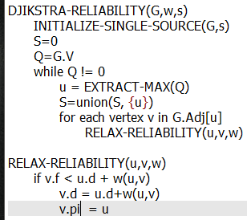

Djikstra’s for the MAX reliability rather than MIN path. Extract-min replaced with extract-max,

Relax checks if less than instead of greater than. The reliability measure replaces weights.

2. Give a simple example of a directed graph with negative-weight edges for which Dijkstra’s algorithm produces incorrect answers. Why doesn’t the proof of Theorem 24.6 go through when negative-weight edges are allowed?

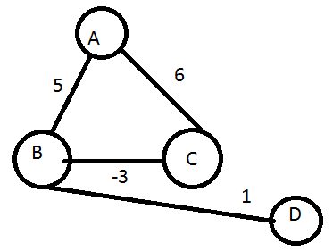

Djikstra would say that the shortest path (A,B) would be 5, but because of a negative weight, the actual shortest path (A,B) would be 3

The problem with Theorem 24.6 occurs because it assumes all the weights on the path are non-negative in order to to allow y.d to be equal to delta(s,y) to be less than or equal to u.d (this goes on to show that y.d = u.d). When there is a negative weight, this relation does not work and the equality is not necessarily maintained.

3. Prove This: Let G = (V,E) be a weighted, directed graph with source vertex s and weight function w : E -> ℝ, and assume that G contains no negative-weight cycles that are reachable from s. Then, for each vertex v in V, there is a path from s to v if and only if BELLMAN-FORD terminates with v.d < ∞ when it is run on G.

The “No Path Property” states that iff there is no path from s to v then v.d=delta(s,v) = infinity

To prove Corollary 24.3 we can simply take the logical converse of the no path property:

iff v.d < infinity, then there is a path from s to v

4. Give an efficient algorithm to find the length (number of edges) of a minimum-length negative-weight cycle.

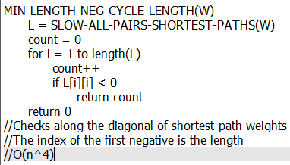

5. Modify the FLOYD-WARSHALL procedure to compute the 𝚷(k) matrices according to equations (25.6) and (25.7).

